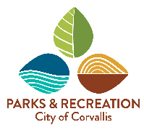
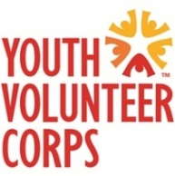
2022-2023 Youth Advisory Board Group Expectations and Requirements
Youth Advisory Board (YAB) is a group of highly expectional young adults who have shown great leadership and enthusiasm while volunteering with Youth Volunteer Corps. Being on this board is a privilage and there are expectations and requirements to follow in order to maintain membership.

- We will have meetings once a month to discuss current and future YVC event planning. Members will be expected to attend all meetings and if they won’t be there they need to notify the YAB advisor in advance.
- A member of YAB can miss no more than five meetings throughout the year. YAB will go from September until the end of the school year in June.
- All members are required to be active and participate in meetings.
- All members will attend each YAB event outside of the meetings.
- All members are required to attend six YVC volunteer events throughout the year.
- Spread the word of YVC to fellow peers through word of mouth, posting flyers or social media.
- Communicate! Call, email, text, write, etc. about events, absences, questions, etc.
- If members are not following a requirement they will first receive a warning then after that they may be subject for removal from the group.
- Lead by EXAMPLE (be a role model and a positive example to your peers)
- Have fun!

If you understand these requirements and feel comfortable fulfilling them please sign below then have your parent or guardian sign as well. If you have any questions feel free to contact Zach Johnson at Zachary.Johnson@corvallisoregon.gov or 541-766-6467.

YAB Member Signature: _________________________________ Date: ______________

